Green Schools’ Newsletter 15th March 2022
In September 2019, we began the process of achieving our third Green Flag, on the theme of ‘water.’ We have to follow seven steps to achieve this flag.
Step 1- Ár gCoiste – Our Committee
We invited pupils from every class to join our committee. We had a great response. Everyone was very enthusiastic. Our committee has changed over the past three years. This is our current committee.
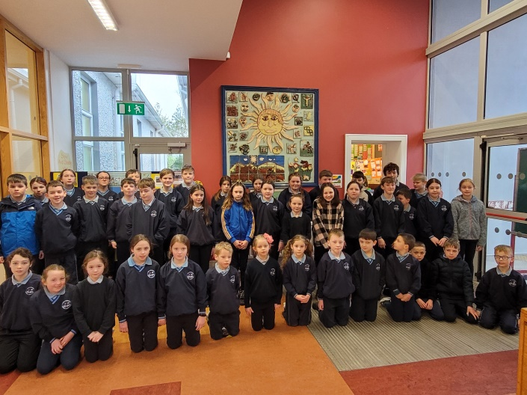
Step 2 –Athbhreithniú - Review
We did a review of the situation in relation to water in the school. We carried out a survey and found that there was a good level of awareness of the need to save water. However, there was room for improvement in leaving taps running unnecessarily. We also did a litter and waste and energy review, as we are continuing with these themes.
Step 3 – Plean Oibre – Action Plan
We devised an action plan to help us reduce water and we reviewed it regularly. One of our activities was a poster competition to raise awareness of saving water. We had wonderful entries from all classes. We devised a rota for litter wardens and we reminded everyone to turn off lights and boards at break. The Infants give us a daily reminder, over the intercom.
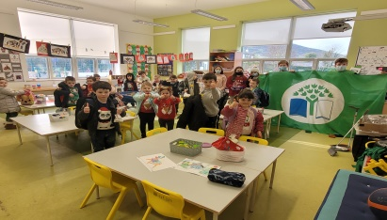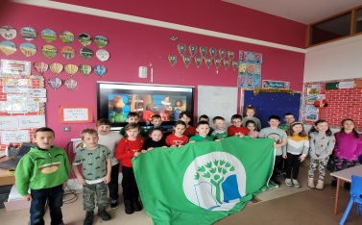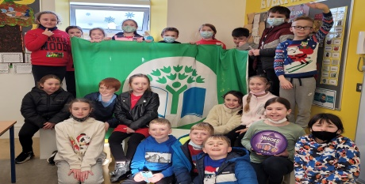
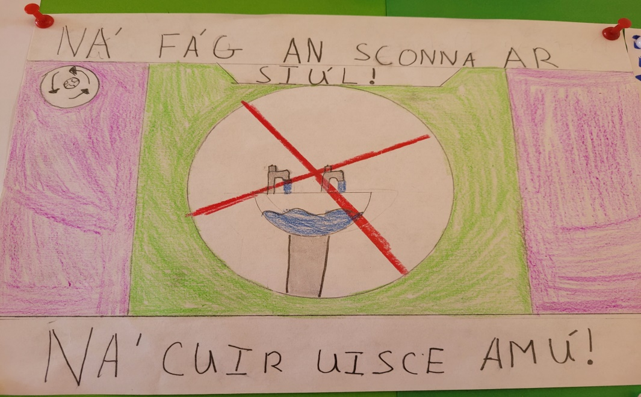

Step 4 – Coimeád Súil Air! – Monitor and Evaluate
We measured the average water use per person per school day in February 2020 and in February 2022 by reading the water meter and we compared our results. In 2022 we used an average of 8.235 litres of water per person per school day. This has been reduced from 9.3 litres per person per day in 2020, a reduction of about 11%.
Step 5 – Obair sa Rang – Curriculum
We linked the theme of ‘water’ with Climate Change, the work of Irish Aid on the Global Development Goals and Trócaire’s work in Zimbabwe. We are linking it with Science and exploring solar energy. We are also linking it with Art in making posters and with Engineering in designing toys with recyclable or recycled materials. Of course we also looked at the uses of water, the topic of groundwater, bees , the water cycle and water conservation.
Step 6 – Ag Scaipeadh an Scéil – Informing and Involving
We use the school intercom and the Green Schools’ Board to keep everyone up to date. We are updating our website and we are preparing a Green Schools’ Newsletter to be sent to the Board of Management, Staff, Parents’ Association and Parents. After our Action Day on March 21st and World Water Day on 22nd March, as well as our Assessment Visit, we will prepare another newsletter.
Step 7 – An Cód Glas – Our Green Code! 