**Nicker National School**

**Tel: (061) 384761 email:** [**nickerprimaryschool@gmail.com**](mailto:nickerprimaryschool@gmail.com) **website:** [**www.nickerns.com**](http://www.nickerns.com)

|  |  |
| --- | --- |
| **New entrants**  **Information Booklet for Parents** | Prepare the child for the path, not the path for the child. |

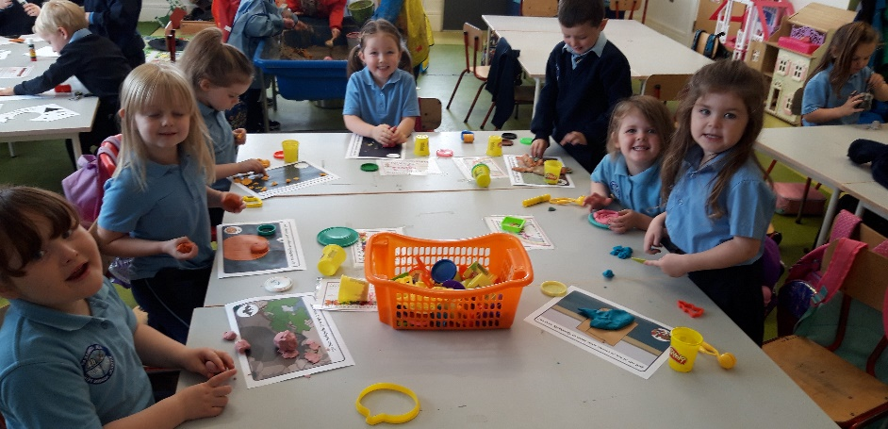

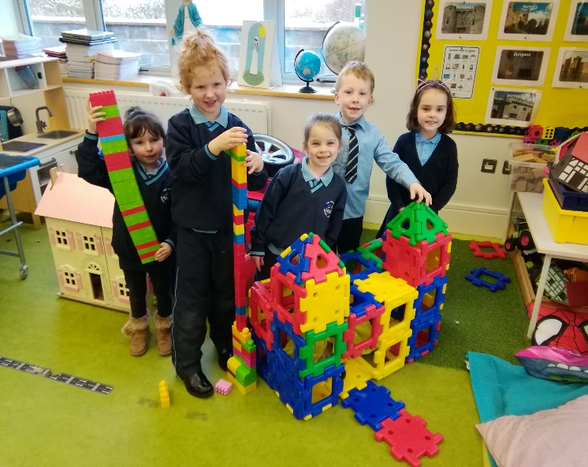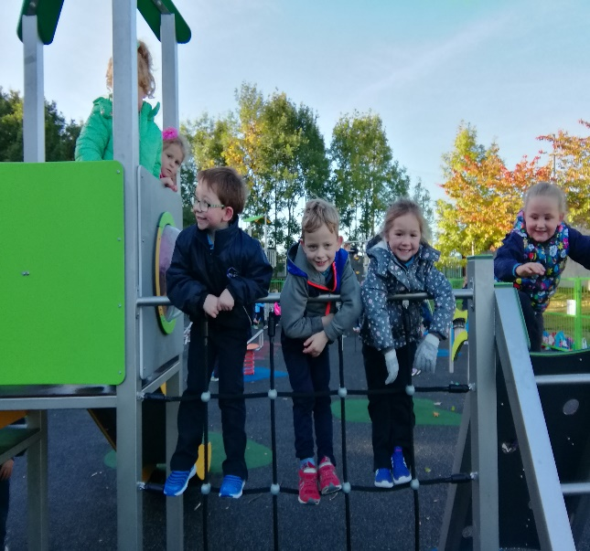

**Before your child starts**

Please ensure that your child is as **independent** as possible – physically, emotionally and socially.

Some of the following areas can pose a challenge when beginning school:

* opening/closing bags and lunchboxes
* zipping/buttoning jackets
* taking off/putting on their own jumper. The children will need to be able to do this when putting on their Art aprons or for warm days at play on the yard
* toileting and alerting school staff when he/she needs the toilet
* knowing that it is OK to ask for help

Confidence and ease in these areas is essential for a smooth transition to primary school and parents should ensure that their child is able to do **all of the above** before starting school, excepting where there is a significant reason. When purchasing materials for starting school, make sure that your child is able to handle the materials. Avoid buying a lunchbox with a very stiff lid, a jumper which may be too small early in the year, a complicated Art apron, shoes that are very difficult to put on after gymnastics etc.

**The First Day of School**

Your child’s first day at school is an important day which you will remember for the rest of their lives. Your approach as a parent is critical in making it a positive and successful experience. Tell your child about school beforehand; casually talk about it as a happy place where there will be a big welcome for them from their teacher and a place where they will meet new friends.

On the first day your child’s books will be taken from them and their teacher will retain them until such time as they are needed.

* **All items of clothing must be clearly labelled.**
* **All books must be marked with your child’s name on the outside cover.**

# Procedure for your child’s first day

When you arrive at the school gate, you will meet the teacher and the other children. Your child will be invited in to the yard for assembly.

In the interests of your child settling quickly, you are encouraged to leave promptly. Assure your child that you will be back to collect them, say goodbye and leave without delay.

**School Attendance**

At Nicker N.S. we encourage regular and punctual attendance by all pupils. We urge parents to work positively with us in achieving a high standard of school attendance for each child.

When a child is absent from school, the class teacher *must* receive a written explanation from the parent. The Education (Welfare) Act 2000 addresses the area of school attendance. The National Education Welfare Board monitors school attendance. Where a child is absent from school for **twenty** school days or more in a school year, the school principal is *legally* *obliged* to report such to the Welfare Officer.

In the case where a child is removed early from school, we would ask you to sign your child out in the **Sign Out book.**

# Uniform

|  |  |
| --- | --- |
| **Girls** | **Boys** |
| Navy pinafore, skirt or slacks | Navy trousers |
| Tracksuit | Tracksuit |
| Blue shirt or polo shirt | Blue shirt or polo shirt |
| Navy jumper or cardigan | Navy jumper |
| Navy tie with gold stripe | Navy tie with gold stripe |
| Dark shoes/runners  Navy socks | Dark shoes/runners  Navy/black socks |

You are free to purchase the above garments wherever it suits you, however in previous years the Parents’ Association have liaised with ‘Fennessy’s’ in William St., Limerick about same. You will be contacted with further information about this shortly.

The Parents’ Association have also run a book rental scheme. Details of this scheme and the booklist will follow before the end of June.

**Please note that children must wear their full uniform every school day.** Additional items such as hoodies, scarves, sleeveless jackets etc. are not part of the children’s uniform and are not permitted in class. If for any reason your child attends school out of full uniform, an explanatory note is required.

**School Timetable**

* School begins at **9.10am**.
* Infants go home at **1.50pm**.
* All other classes go home at **2.50pm.**
* Children travelling on the bus go home at **2.50pm.**

**Please note:**

On your child’s **first two weeks** in school, **Junior Infants will go home at 12.00 pm** in order to help them to adjust to a longer school day over time. Details for resumption of the normal timetable will follow.

Please make sure that your child is collected on time. Children can get very distressed if the person collecting them is not there on time.

**Breaks**

Mid morning break is from **10:45am – 11.00am**.

Lunch time is from **12:30pm – 1:00pm**

**Collection from school**

It is not acceptable that children, other than those travelling by bus and on the bus route, stay in the infant room after 1.50pm.This is in accordance with Department of Education and Skills rules and regulations for Primary Schools.

**School Holidays**

Parents will receive details of all school holidays for the academic year in September. It can be very disruptive in the classroom if children go away on holiday in June or at any other time of the year and we appeal to parents to co-operate with the school policy on this matter.

A child must **never** leave the classroom without their teacher’s permission.

A child must **never** leave the playgrounds without the permission of the class teacher or school principal.

A note is essential when a child has to leave the school early, as the parents then accept responsibility for the child’s safety. Alternatively parents may use the sign out book which will be located in the office or alternatively in the principal’s room.

**Classroom rules and procedures**

* It is expected of every child at school that they behave in a fashion which is conducive to their own happiness and well being, as well as to the happiness and well-being of those around them. Included with this document is a copy of the school discipline policy.
* Each class is assigned to a particular yard where they will play with their peers at break times.
* When the bell rings at the end of lunch break, children immediately line up in single file with their class and wait quietly for the teacher to take them indoors.
* On wet days, children eat their lunch, go to the toilet and then remain in their classrooms. Some toys, colouring, writing, computer or board games are provided.
* It is not acceptable for children to stay in the classroom at lunchtime due to illness. Additional supervision cannot be provided in such cases.
* Pupils are expected to treat the school, school’s property and the school surroundings with care and respect.
* For more detail on rules and procedures, please refer to the school’s code of behaviour.

**Lunches and Healthy Eating Policy**

We promote a healthy eating policy in Nicker NS. In an effort to cut down on the children’s consumption of unhealthy foods, the following items are not allowed inside the school or on the school grounds:

* Crisps
* Chewing Gum
* Fizzy Drinks
* Sweets
* Bars
* Lollipops
* Biscuits
* Nutella or chocolate spread

In addition, some children in the school are susceptible to allergic reactions to foods such as nuts, fish and eggs. Please avoid same in your child’s lunchbox if there is a child with such allergies in your child’s classroom. You will be advised of same, if applicable.

We urge parents to provide **healthy lunches** for their children.

Some suggestions would include:

Unsweetened yogurt, vegetables, fruit, cheese, sandwiches, scones, bread rolls, pitta bread, wraps, crackers etc. Suggested drinks might include milk, water, fruit juice.

In the interests of promoting healthy eating, we would also request that you do not send birthday cakes/birthday treats to school for distribution among the other children by the teacher.

**Hygiene**

In an effort to promote hygiene, and to educate our young people in personal hygiene, it is essential that children’s hair is checked regularly for head lice, especially in September and January. A note will be sent to parents if there is an outbreak of headlice in their child’s classroom. It is essential that the guidelines on this note are followed by everyone to ensure that the headlice do not continue to spread.

**Hand Hygiene**

It is very important that your child is able to wash their hands properly and independently. They will be shown how to do this in school but it would be very helpful to them if they were familiar with correct handwashing before this point.We would also ask you to ensure that your child is in the habit of washing their hands after using the toilet and before coming to school.

**Homework**

Homework is considered a necessary and important aspect of school life. At Infant level, the children receive a homework list at the beginning of the week. This homework list should be signed by the parent each evening, ensuring that each part has been completed. This is to show that the child has done their best and that the work has been completed. This list can also be a useful means of communication between the class teacher and parent.

Children in Junior Infants begin homework around the end of October. Remember how important it is to read and talk to your child every day about school. This develops their language, general understanding and creates awareness in the child of the importance of school and of doing their best at all times in school.

Children are expected to behave well and show respect to their peers and members of staff. Teachers will keep a written record of instances of misbehaviour in their classes or on the yard. This record is to ensure that the health and welfare of all children is being catered for. We endeavour to praise children for behaving well and to encourage and respond favourably to positive behaviour. We ask that parents encourage good behaviour at home as well as in school. This provides the child with a consistent, positive approach to behaviour, with parents and teachers working together.

**Communication**

Parents should ensure that they can be contacted by phone during school hours in the event of their child becoming ill. If Parents are not contactable, the school should have an alternative phone number of a person who will take responsibility for the child in the absence of the parent/guardian. Please ensure that the completed enrolment form has this important information and keep the secretary of the school informed regarding any changes in contact phone numbers.

**Mobile Phones**

Please note that children are ***not allowed*** mobile phones in school, during any school activities or out- of- school events.

The school phone no. is **061 384761** and will be answered by the school secretary between 9.00am and 12.30pm.