**Log in instructions for the two main publishers, Folens online and CJ Fallon online**

**The following are the login details for Folens Online**

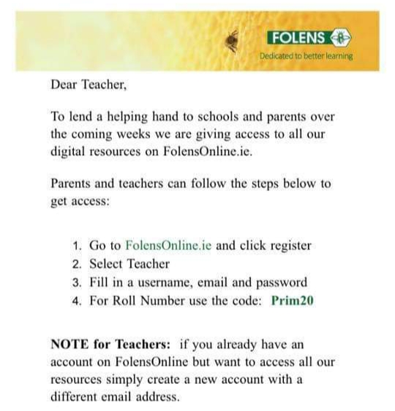

**CJ Fallon Online login details:**

**The homepage on CJ Fallon has a direct link for parents to log in during the COVID-19 crisis. Go to CJ Fallon.ie and follow the instructions.**

**Reading**

|  |  |  |  |
| --- | --- | --- | --- |
| **Class** | **Website/Publisher** | **Activities** | **Link** |
| **Junior Infants** | **Folens online** | * Look Out Teddy * Splash * The Lost Ball | <https://www.folensonline.ie/home/library/programmes/rzji/resources/>  **These books have an audio option. A child’s voice can be heard reading these books when the audio button is pressed.** |
| **Senior Infants** | **Folens online** | * Stop That Dog * The Big Horse * What a Mess | <https://www.folensonline.ie/home/library/programmes/rzji/resources/>  **These books have an audio option. A child’s voice can be heard reading these books when the audio button is pressed.** |
| **Juniors & Seniors** | **CJ Fallon online** | * A New Baby * Stories For You * Visiting * Look at This * Jen Plays Tricks * Len Likes to Hide * Hello! * I See, I See | **The homepage on CJ fallon has a direct link for parents to log in during the COVID-19 crisis.**  <https://my.cjfallon.ie/dashboard/resources>  There is also an extensive list of books under the ***Wonderland*** programme on this website.  **Continue to revise all blue and yellow tricky words.**  These are sight words that cannot be sounded out  Senior Infants can include Red Tricky words also |

Phonics

* Revise the first two groups of Jolly Phonics sounds using the Sounds Booklet in the homework folder. These sounds are s, a, t, I, p, n, c, k, e, h, r, m, d. Listen to these songs using youtube/spotify. List words containing these words. Play eye spy.
* Blending orally: using the sounds above the parent says three sounds slowly to make a word e.g. h-a-t and the child has to say the word. Swap the first sound to make rhyming words e.g. h-a-t, s-a-t, m-a-t
* [www.starfall.com](http://www.starfall.com)
* Senior Infants can revise the lists of words on their Sight and Sounds Book on pages 7, 13, 17, 21
* From Twinkl:

1. I-Can-Read-Phase-2-Words-Activity-Sheet-Pack.
2. cvc-word-activity-booklet
3. cvc-ccvc-and-cvcc-activity-sheet
4. phonics read and draw activity sheet
5. phonics read and write activity sheet

I have attached these in PDF. I understand that you may not have access to a printer, however, it would be possible to create your own simple version of some of these work sheets on a blank page.

Writing

Juniors

Practice of letter formation is crucial. Your child can trace letters/words that you write for them or write them using the Sight and Sounds book as a guide.

* They can also trace the letters on this book using their finger.
* Tracing letters in sand, rice, flour etc…
* Drawing or writing with chalk outside
* Any drawing or colouring activities
* Copying letters or words that the parent has written
* Parent calls out a sound, child writes the sound
* Twinkl worksheets above if a printer is available

Seniors

* Practice of letter formation.
* Tracing or copying words, letters or sentences from parent's writing.
* Write shorts notes, cards, greetings, messages, lists
* Twinkl worksheets above if printer is available.
* Home version of ‘My News’. Parent writes 3 sentences and childs copies underneath. Child tries to write one line of their own work.

***Gaeilge***

We have been using CJ Fallon’s Céim ar Chéim scheme in school. I cannot see that this is available to use at home but the **Folens Online programme, Abair Liom A**, would work well at home.

Log in to **Folens online** as above.

<https://www.folensonline.ie/home/library/programmes/abair-liom-junior-infants/resources/>

or

Search **Abair Liom A** using the website’s own search option

Click on ***resources***

Click on ***theme***

You will see an option of ten themes. The following two themes can be revised:

|  |  |  |  |
| --- | --- | --- | --- |
| **Theme** | **Vocabulary** | **Phrases** | **Poem** |
| 1. **Mé Féin (Myself)** | dearg, súil, cluas, lámh, srón, béal, gruaig, méar, fiacla, cos, ceann, madra | Cé thusa? Is mise Seán  Seo í mo lámh etc…. | Lámh, lámh eile a haon, a dó |
| 1. **Bia (Food) An Bosca Lóin** | glas, bosca lóin, úll, oráiste, ceapaire, uisce, bainne, ag ithe, ag ól | Tá ___ i mo bhosca lóin.  Tá mé ag ithe/ag ól.  Is maith/Ní maith liom ___. | Listen to the song  Cad atá i do bhosca lóin? |

The conversations can be played and listened to repeatedly. There is a nice, simple question (ceisteanna) game to go with each converstion (comhrá).

There is also an interactive game to go with each theme.

Maths

* Tracing numbers for correct number formation. Parent to dot numbers if necessary.

0-5 for Junior Infants

0-10 for Senior Infants

* Combining/adding sets of objects, up to 5 for Juniors, up to 10 for Seniors. Using actual items such as lego pieces. Counting items separately and then put together and count all items together. Take a set of objects e.g. 6 grapes. Child closes eyes and you hide some of the grapes under a bowl. Child must figure out how many are hidden.
* Capacity: Water play with a variety of containers. **Language: full/empty, holds more/holds less**. Checking if different containers hold more or hold less. Empty cartons of milk and juice could be used for this. Filling a basin or bucket using different containers. Talking about which containers would fill it faster. This can be carried out outdoors and sand and water play can be incorporated. Role play of a coffee shop and pouring tea and drinks could be incorporated into this.
* Reciting days of the week. Knowing what day it is today
* My Day – language: morning, lunchtime, evening, bedtime

**The Importance of Play**

The value of play and imagination cannot be underestimated. During school time the children enjoy learning through play in ‘Aistear’. The following are the stations in Aistear depending on the theme we are covering

**Junk Art:** Building things from recyclables such as cardboard boxes, cereal boxes, kitchen roll inserts

**Role play**: Restaurant, vet, nurses, doctors, school, home, babies, firefighters, ambulance, farmers. The children could also be provided with a dress up box of old adult clothes and accessories and use their imaginations to create scenarios with these.

**Play doh**: If you are feeling very creative the following is a recipe for homemade play doh:

* 1 cup flour
* 2 tsp bread soda
* 1/2 cup salt
* 1 tbsp cooking oil Olive oil or vegetable oil
* 1 cup water
* Food colouring and glitter (optional)

**Small world play**: this is farm play, zoo, action figures, dolls house, castles, army or any miniature life scenes

**Writing:** Drawing, colouring or writing

**Building/Construction**: use of any sort of building blocks, lego, straws, wooden blocks to create something from imagination

**Sand and water play**: Digging, building, searching, moulding, pouring and creating with sand and water.

**Outdoor activities:**

My Five Senses Scavenger Hunt from Twinkl

Bug hunt, Teddy Bears Picnic, build a den, make an obstacle course, paint rocks, chalk on yard, water/sand play, outdoor kitchen.