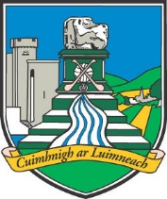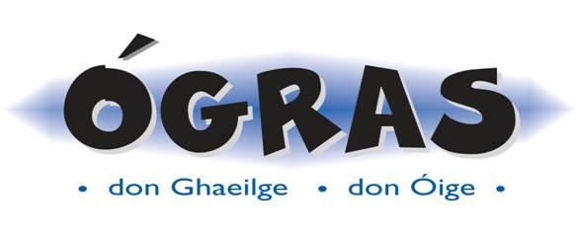

***“IMPROVE A YOUNG PERSON’S IRISH THROUGH FUN ACTIVITIES”***

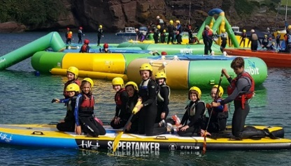 Image may contain: 1 person 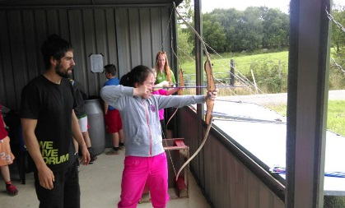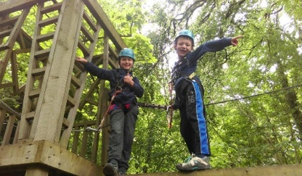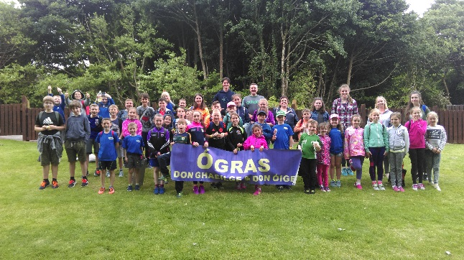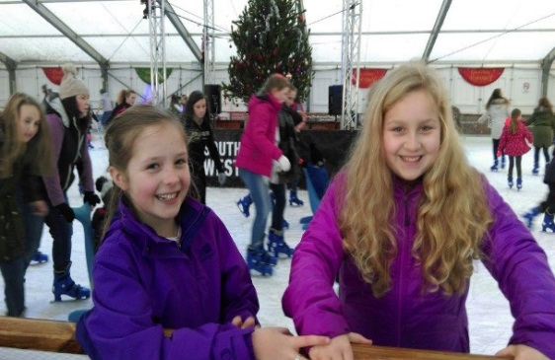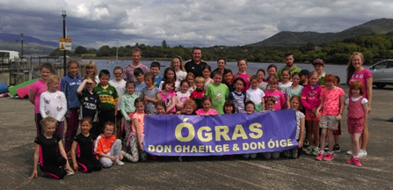Image may contain: 4 people, people smiling, shoes, basketball court, child, outdoor and indoor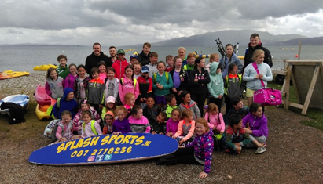

***Tugann Club Óg-Ógras deis do dhaoine óga taitneamh a bhaint as imeachtaí trí mheán na Gaeilge. An Óg-Ógras Club provides young people aged between 7 & 12 with an opportunity to practise their Irish while engaging in a wide range of fun activities & trips. It is intended to commence a club in the Pallasgreen area. An information evening along with a session of fun and games will take place at the ‘High Nelly Café’ on Thursday, June 7th at 7pm. Refreshments for both young and old will be served. Breis Eolais/Further info. from Éilín de Grás on 086 8349988***



***“IMPROVE A YOUNG PERSON’S IRISH THROUGH FUN ACTIVITIES”***

 Image may contain: 1 person ******Image may contain: 4 people, people smiling, shoes, basketball court, child, outdoor and indoor******

***Tugann Club Óg-Ógras deis do dhaoine óga taitneamh a bhaint as imeachtaí trí mheán na Gaeilge. An Óg-Ógras Club provides young people aged between 7 & 12 with an opportunity to practise their Irish while engaging in a wide range of fun activities & trips. It is intended to commence a club in the Pallasgreen area. An information evening along with a session of fun and games will take place at the ‘High Nelly Café’ on Thursday, June 7th at 7pm. Refreshments for both young and old will be served. Breis Eolais/Further info. from Éilín de Grás on 086 8349988***